Johnson Trotter Algorithm

#include <stdio.h>

#include <stdlib.h>

int flag = 0;

int swap(int *a, int *b) {

int t = *a;

*a = *b;

*b = t;

}

int search(int arr[], int num, int mobile) {

int g;

for (g = 0; g < num; g++) {

if (arr[g] == mobile)

return g + 1;

else {

flag++;

}

}

return -1;

}

int find_Mobile(int arr[], int d[], int num) {

int mobile = 0;

int mobile_p = 0;

int i;

for (i = 0; i < num; i++) {

if ((d[arr[i] - 1] == 0) && i != 0) {

if (arr[i] > arr[i - 1] && arr[i] > mobile_p) {

mobile = arr[i];

mobile_p = mobile;

} else {

flag++;

}

} else if ((d[arr[i] - 1] == 1) && i != num - 1) {

if (arr[i] > arr[i + 1] && arr[i] > mobile_p) {

mobile = arr[i];

mobile_p = mobile;

} else {

flag++;

}

} else {

flag++;

}

}

if ((mobile_p == 0) && (mobile == 0))

return 0;

else

return mobile;

}

void permutations(int arr[], int d[], int num) {

int i;

int mobile = find_Mobile(arr, d, num);

int pos = search(arr, num, mobile);

if (d[arr[pos - 1] - 1] == 0)

swap(&arr[pos - 1], &arr[pos - 2]);

else

swap(&arr[pos - 1], &arr[pos]);

for (int i = 0; i < num; i++) {

if (arr[i] > mobile) {

if (d[arr[i] - 1] == 0)

d[arr[i] - 1] = 1;

else

d[arr[i] - 1] = 0;

}

}

for (i = 0; i < num; i++) {

printf(" %d ", arr[i]);

}

}

int factorial(int k) {

int f = 1;

int i = 0;

for (i = 1; i < k + 1; i++) {

f = f * i;

}

return f;

}

int main() {

int num = 0;

int i;

int j;

int z = 0;

printf("Johnson trotter algorithm to find all permutations of given numbers \n");

printf("Enter the number\n");

scanf("%d", &num);

int arr[num], d[num];

z = factorial(num);

printf("total permutations = %d", z);

printf("\nAll possible permutations are: \n");

for (i = 0; i < num; i++) {

d[i] = 0;

arr[i] = i + 1;

printf(" %d ", arr[i]);

}

printf("\n");

for (j = 1; j < z; j++) {

permutations(arr, d, num);

printf("\n");

}

return 0;

}

**OUTPUT**

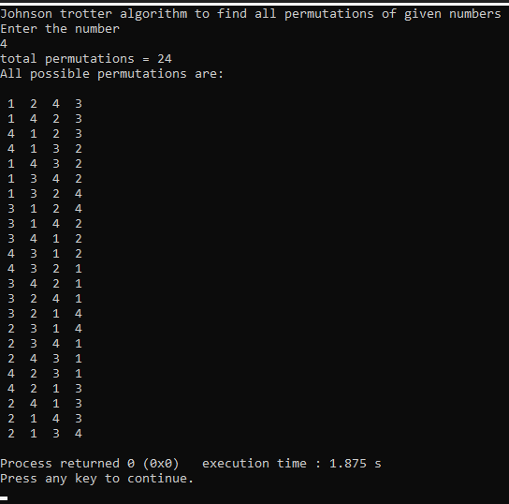

[**Find the Kth Largest Integer in the Array**](https://leetcode.com/problems/find-the-kth-largest-integer-in-the-array/)**-LEETCODE**

You are given an array of strings nums and an integer k. Each string in nums represents an integer without leading zeros.

Return *the string that represents the*kth*largest integer in*nums.

Note: Duplicate numbers should be counted distinctly. For example, if nums is ["1","2","2"], "2" is the first largest integer, "2" is the second-largest integer, and "1" is the third-largest integer.

**CODE**

int compare(const void *a, const void *b) {

    const char *str1 = *(const char **)a;

    const char *str2 = *(const char **)b;

    int len1 = strlen(str1);

    int len2 = strlen(str2);

    if (len1 != len2) {

        return len2 - len1;

    }

    return strcmp(str2, str1);

}

char* kthLargestNumber(char **nums, int numsSize, int k) {

    qsort(nums, numsSize, sizeof(char*), compare);

    return nums[k - 1];

}

**OUTPUT**

